*PIZZA SALES SQL QUARIES*

A.KPI

**1.Total Revenue:**

SELECT SUM(total_price) AS Total_Revenue FROM pizza_sales

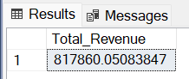

2.Average Order Value:

SELECT SUM(total_price)/COUNT(DISTINCT order_id) AS Average_order_value FROM pizza_sales

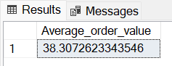

3.Total Pizzas Sold:

SELECT SUM(quantity) AS Total_Pizzas_Sold FROM pizza_sales

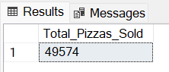

4.Total Orders:

SELECT COUNT(DISTINCT order_id) AS Total_Orders FROM pizza_sales

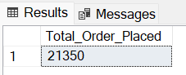

5.Average Pizzas Per Order:

SELECT CAST(CAST(SUM(quantity) AS DECIMAL(10,2))/CAST(COUNT(DISTINCT order_id) AS DECIMAL (10,2)) AS DECIMAL(10,2)) AS Average_Pizza_Per_Order FROM pizza_sales

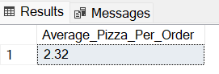

B.CHART QUARIES:

1.Daily Trend For Total Orders:  
SELECT DATENAME(DW,order_date) AS Order_day,COUNT(DISTINCT order_id) AS Total_Orders

FROM pizza_sales

GROUP BY DATENAME(DW,order_date)

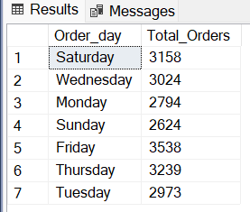

2.Hourly Trend For Total Orders:

SELECT DATEPART(HOUR,order_time) AS Order_Hour,COUNT(DISTINCT order_id) AS Total_Orders

FROM pizza_sales

GROUP BY DATEPART(HOUR,order_time)

ORDER BY DATEPART(HOUR,order_time)

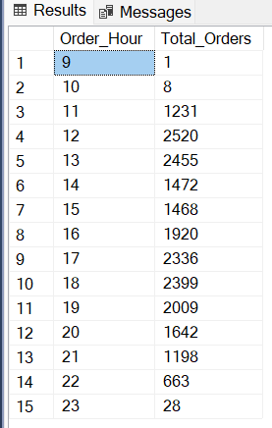

3.Percentage Of Sales By Pizza Category:

SELECT pizza_category AS Pizza_Category,SUM(total_price)*100/(SELECT SUM(total_price) FROM Pizza_sales) AS Percent_Sales

FROM Pizza_sales

GROUP BY pizza_category

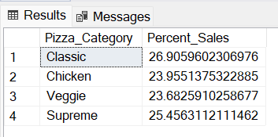

**NOTE:**

*If we want to apply the Monyj,Quarter,Week filters to the above quires you use WHERE clause. Examples*

SELECT DATENAME(DW,order_date) AS Order_day,COUNT(DISTINCT order_id) AS Total_Orders

FROM pizza_sales

WHERE MONTH(order_date)=1

GROUP BY DATENAME(DW,order_date)

*Here MONTH(order_date)=1 indicates output of 1st month i.e. January

SELECT DATENAME(DW,order_date) AS Order_day,COUNT(DISTINCT order_id) AS Total_Orders

FROM pizza_sales

WHERE DATEPART(Quarter,order_date)=1

GROUP BY DATENAME(DW,order_date)

*Here DATEPART(Quarter,order_date)=1 indicates the results of quarter 1.

4.Percent Of Pizza Sold By Pizza Size:

SELECT pizza_size AS Pizza_size,SUM(total_price)*100/(SELECT SUM(total_price) FROM Pizza_sales) AS Percent_Sales

FROM Pizza_sales

GROUP BY pizza_size

ORDER BY Percent_Sales DESC

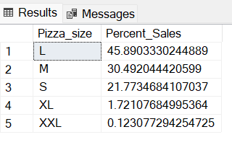

5.Pizza Sold By Pizza Category:

SELECT(pizza_category) AS Pizza_Category, SUM(quantity) AS Total_Pizza_Sold

FROM pizza_sales

GROUP BY pizza_category

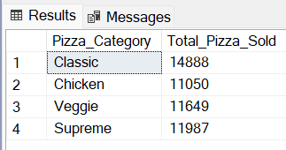

6.Top 5 Best Seller By Total Pizza Sold:

SELECT TOP 5 pizza_name AS Seller, SUM(quantity) AS Total_Pizza_Sold

FROM pizza_sales

GROUP BY pizza_name

ORDER BY Total_Pizza_Sold DESC

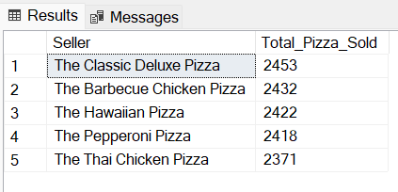

7.Bottom 5 Worst Seller By Total Pizza Sold:

SELECT TOP 5 pizza_name AS Seller, SUM(quantity) AS Total_Pizza_Sold

FROM pizza_sales

GROUP BY pizza_name

ORDER BY Total_Pizza_Sold

